**EchoClientServer**

*Client Code:*

import java.io.*;

import java.net.*;

private void CSUBMITActionPerformed(java.awt.event.ActionEvent evt) {

// TODO add your handling code here:

try {

String cipaddr = CIPADDR.getText();

Integer cportno = Integer.parseInt(CPORTNO.getText());

String cmsg = CMSG.getText();

Socket s = new Socket(cipaddr, cportno);

DataInputStream dis = new DataInputStream(s.getInputStream());

DataOutputStream dos = new DataOutputStream(s.getOutputStream());

dos.writeUTF(cmsg);

String newStr = dis.readUTF();

CRESPONSE.append("/n" + newStr);

} catch (Exception e) {

e.printStackTrace();

}

SERVER CODE :

public class Server extends javax.swing.JFrame implements Runnable {

public void run(){

String sipaddr = SIPADDR.getText();

int sportno = Integer.parseInt(SPORTNO.getText());

try{

ServerSocket ss = new ServerSocket(sportno, 5, InetAddress.getByName(sipaddr));

Socket s = ss.accept();

DataInputStream dis = new DataInputStream(s.getInputStream());

DataOutputStream dos = new DataOutputStream(s.getOutputStream());

String req = dis.readUTF();

SMSG.append("Client [" + s.getInetAddress() + "] " + req);

dos.writeUTF(req);

s.close();

}

catch(Exception e){

e.printStackTrace();

}

}

private void SBUTTONActionPerformed(java.awt.event.ActionEvent evt) {

// TODO add your handling code here:

Thread t = new Thread(this, "server");

t.start();

SBUTTON.setEnabled(false);

SMSG.append("Server is Listening \n");

}

**BULLETIN BOARD**

*CLIENT CODE :-*

private void BBSendBtnActionPerformed(java.awt.event.ActionEvent evt) {

// TODO add your handling code here

try{

String ip=BBIPADDR.getText();

Integer port=Integer.parseInt(BBPORT.getText());

Socket s=new Socket(ip,port);

DataOutputStream dos=new DataOutputStream(s.getOutputStream());

String str=BBMSG.getText();

dos.writeUTF(str);

BBResp.append(str+"\n");

s.close();

}

catch(Exception e)

{ e.printStackTrace();

}

}

*SERVER CODE :-*

public void run()

{

try{

Integer port=Integer.parseInt(BBPORTNO.getText());

ServerSocket ss=new ServerSocket(port);

while(true)

{

Socket s=ss.accept();

DataInputStream dis=new DataInputStream(s.getInputStream());

DataOutputStream dos=new DataOutputStream(s.getOutputStream());

String str=dis.readUTF();

BBRES.append("\n"+s.getInetAddress()+" : "+str);

dos.writeUTF(str);

}

}

catch(Exception e)

{

e.printStackTrace();

}

}

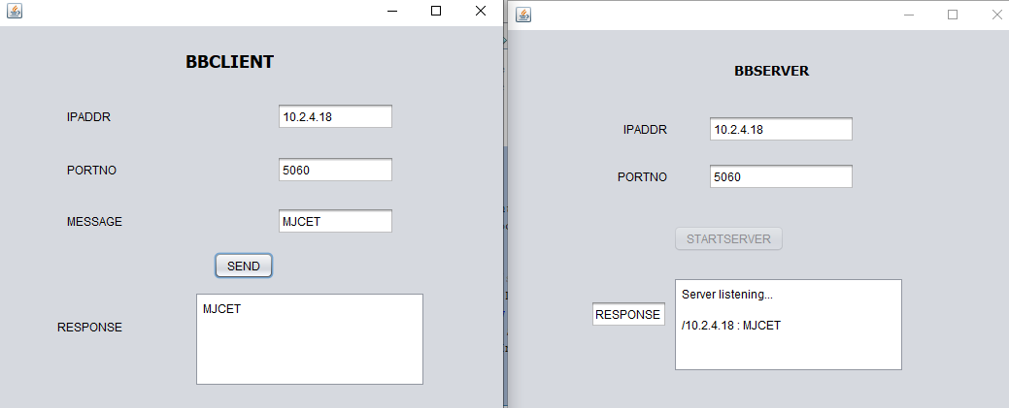

**CHAT APPLICATION**

public void run()

{

try{

Integer port=Integer.parseInt(SPORT.getText());

ServerSocket ss=new ServerSocket(port);

while(true)

{

Socket s=ss.accept(); //s is a socket which has got connection i.e., full association tuple

DataInputStream dis=new DataInputStream(s.getInputStream());

DataOutputStream dos=new DataOutputStream(s.getOutputStream());

String str=dis.readUTF();

SRESP.append("\n"+s.getInetAddress()+" : "+str);

dos.writeUTF(str);

}

}

catch(Exception e)

{

e.printStackTrace();

}

private void SENDBtnActionPerformed(java.awt.event.ActionEvent evt) {

// TODO add your handling code here:

try{

String ip=CIP.getText();

Integer port=Integer.parseInt(CPORT.getText());

Socket s=new Socket(ip,port);

DataInputStream dis=new DataInputStream(s.getInputStream());

DataOutputStream dos=new DataOutputStream(s.getOutputStream());

String str=CMSG.getText();

dos.writeUTF(str);

String newStr=dis.readUTF();

CMSG.append("\n"+newStr);

s.close();

}

catch(Exception e)

{

e.printStackTrace();

}

}

private void STARTSERVERBtnActionPerformed(java.awt.event.ActionEvent evt) {

// TODO add your handling code here:

Thread t=new Thread(this,"t1");

t.start();

SRESP.append("Server listening...\n");

STARTSERVERBtn.setEnabled(false);

}

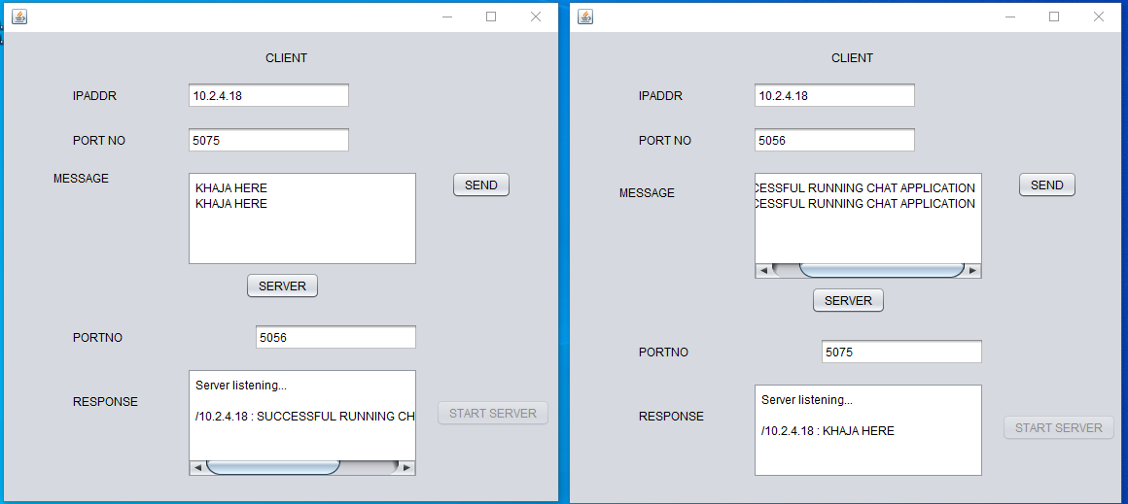

**NAME SERVER(DNS SERVER)**

**CLIENT CODE :-**

private void NSCBtnActionPerformed(java.awt.event.ActionEvent evt) {

// TODO add your handling code here:

try {

String ip = CIP.getText();

int port =Integer.parseInt(CPORT.getText());

Socket s=new Socket(ip,port);

DataInputStream dis=new DataInputStream(s.getInputStream());

DataOutputStream dos=new DataOutputStream(s.getOutputStream());

String domain=NSDomain.getText();

dos.writeUTF(domain);

String response=dis.readUTF();

NSCMsg.append(response+"\n");

s.close();

}

catch(Exception e)

{

e.printStackTrace();

}

}

**SERVER CODE :-**

public void run()

{

try{

int sPort=Integer.parseInt(Sportno.getText());

ServerSocket ss=new ServerSocket(sPort);

while(true)

{

Socket s=ss.accept();

DataInputStream dis=new DataInputStream(s.getInputStream());

DataOutputStream dos=new DataOutputStream(s.getOutputStream());

String req=dis.readUTF();

NSSResp.append(s.getInetAddress().toString()+"/");

try{

BufferedReader br=new BufferedReader(new InputStreamReader(new FileInputStream("DNSData.txt")));

String fInput=br.readLine();

int flag=0;

while(fInput!=null)

{

StringTokenizer stk=new StringTokenizer(fInput);

String dname=stk.nextToken();

String dIP=stk.nextToken();

if(req.equals(dname))

{

dos.writeUTF(dname+" - The IP for the URL is : "+dIP+"\n");

flag=1;

}

fInput=br.readLine();

}

if(flag==0)

dos.writeUTF(req+"/NOT FOUND");

}

catch(Exception e)

{

e.printStackTrace();

}

}

}

catch(Exception e)

{

e.printStackTrace();

}

}

private void StartActionPerformed(java.awt.event.ActionEvent evt) {

// TODO add your handling code here:

{

Thread t=new Thread(this,"ns");

t.start();

Start.setEnabled(false);

NSSResp.append("Server is listening...\n");

}

}

